Scientific journal «OBRABOTKA METALLOV
METAL WORKING AND MATERIAL SCIENCE»

Dear authors, carefully read the rules for writing a paper on the journal's website!

paper template
The blue color indicates explanations as to what exactly and how it should be written in this section or subsection.
After making the appropriate corrections to the sections of the paper, these blue hints should be deleted. In the template, one should put all the materials and data that should be printed in the journal (including figures and tables). The filled paper template should be saved on the computer and uploaded to the journal's website.
__________________________________________________________________________

Structure features of B₄C-Ni-Р plasma coatings
(The title should reflect the main idea of the research performed and be as brief as possible.)

Elena E. Kornienko ^{1, a,*}, Viktor I. Kuz’min ^{2, b}, Alexander A. Sivkov ^{3, c}
(Full list of all the authors. The name and surname of the author (s) should be written in full.)

¹ Novosibirsk State Technical University, 20 Prospect K. Marksa, Novosibirsk, 630073, Russian Federation
² Khristianovich Institute of Theoretical and Applied Mechanics SB RAS, 4/1 Institutskaya str., Novosibirsk, 630090, Russian Federation
³ National Research Tomsk Polytechnic University, 30 Lenin Avenue, Tomsk, 634050, Russian Federation
(Полное название организации для каждого из авторов с указанием улицы, номера дома, города, почтового индекса и страны.)

ª http://orcid.org/0000-0002-5874-5422, kornienko_ee@mail.ru, ^{b} http://orcid.org/0000-0002-9951-7821, vikuzmin57@mail.ru,
^{c} http://orcid.org/0000-0002-7685-5502, SivkovAA@mail.ru
(For all the authors, it is NECESSARY to indicate his/her unique identification code ORCID (Open Researcher and Contributor ID) and e-mail. If there is no ORCID, the author should go to https://orcid.org and register in the system. After registering ORCID, author should edit his/her personal data and the publication list (the “empty” ORCID profile is not allowed!))

PAPER INFO

Paper history:
Received: 1 June 2017 (Date of receipt of work in the editorial board. Important: the work should arrive not later than 3 months before the official issue according to the schedule. In exceptional cases, in agreement with the editorial board of the journal, the deadline for the receipt of the paper in the nearest issue may be extended, but not more than for two weeks.)
Revised: (Date is indicated by the editorial board)
Accepted: (Date is indicated by the editorial board)
Available online: (Date is indicated by the editorial board)

Keywords
Plasma spraying,
Boron carbide,
B₄C-Ni-P,
Coating
(Keywords (no more than 15 words and combinations))

ABSTRACT

Abstract for a paper should be: informative (do not contain general words); original; (to reflect the main content of the paper and the results of the research); structured (follow the logic of describing the results in the paper). The volume of the abstract should be at least 250 words !!! The abstract should include the following aspects of the content of the paper: the rationale, the subject, the purpose of the work; method or methodology of the work; results of work; the field of application of the results; conclusions.

For citation: Kornienko E.E., Kuz’min V.I., Sivkov A.A. Structure Features of B₄C-Ni-Р Plasma Coatings. Obrabotka metallov (tekhnologiya, oborudovanie, instrumenty) = Metal Working and Material Science, 2017. no. 3 (76), pp. 30–50. doi: 10.17212/1994-6309-2017-3-30-50. (in Russian)
(The authors indicate an approximate reference to future work in this journal. The editors reserve the right to edit this item.)
* Corresponding author
Kornienko Elena E., Ph.D. (Engineering), Associate Professor
Novosibirsk State Technical University,
20 Prospect K. Marksa,
630073, Novosibirsk, Russian Federation
Tel.: 8 (383) 346-11-71, e-mail: kornienko_ee@mail.ru
(The full name, degree, title, position and affiliation of the author for correspondence are indicated. Also, the address, telephone and e-mail should mandatorily be submitted!)

The main part of the paper
1. Introduction
The introduction should have the volume of 1-2 pages. A short review of the literature on the research problem should be presented, the issues that have not been resolved before should be indicated, and the purpose and objectives of the research should be formulated and justified.

2. Investigation Technique
Theory (for theoretical works) or the experiment technique (for experimental work) should be described. Repeats, unnecessary details and known statements, detailed derivations of formulas and equations should be avoided (give only final formulas, explaining how they were obtained).

3. Results and Discussion
A section containing a brief description of the experimental and/or theoretical data obtained. The statement of results should consist in revealing the discovered regularities, and not in the mechanical retelling of the contents of tables and graphs. The results are recommended to be stated in the past tense. The discussion should contain an interpretation of the results of the study (the correspondence of the results to the research hypothesis, the correlation of the study results, proposals for practical application, suggestions for the future research direction).
Recommendations for typing the text
It is recommended to use one of the last version of Microsoft Word for Windows. Originals format is A4. Recommended fonts: Times New Roman for main text, Symbol for Greek letters. Standard size of font – 14 pt. Recommendations for page parameters – all fields are 2 cm width. Align text to the width. Line spacing is one and a half. The indentation is 1.25 cm. The transfers are included. Drawings, tables, graphs, photographs should be included in the text of the paper.
Do not use more than one space – use indention and tabs.
Do not end the line by pressing the “Enter” key – use it only to start a new paragraph.
Use the features provided by the text editor: automatic creation of footnotes, automatic transfer or automatic hyphenation, creation of lists, automatic indentation, etc.
Do not type Cyrillic characters that are similar in type to Latin letters, and vice versa.
It is inadmissible to replace the dash “–” with a hyphen “-”.
In the text and formulas (including in indices), Latin letters should be typed in italics, and Greek and Russian should be typed regularly.
Decimal figures in Russian texts are typed by comma (0,5), and in English-speaking texts ̶ through the point (0.25 instead of 0.25).
Recommendations for formulas
Mathematical formulas, structural chemical formulas and schemes are arranged in place in the text of the paper.
Signs *, ', ±, single letters of the Greek alphabet, single inclined or bold letters, single variables or notation that have only upper or only lower index, units of measure, numbers in the text, and simple mathematical or chemical formulas (for example, a² + b² = c², H₂SO₄) should be typed in text mode without using the formula editor.
Remote mathematical formulas (formatted as a separate line) should be typed using the Equation Editor (Microsoft Equation). A set of formulas from compound elements, where part of the formula is a table, part is a text, part is an embedded frame, is not allowed.
For formulas typed in the formula editor, common font settings, the size of the characters and its placement should be used. Its forced manual change for individual symbols or elements of formulas is not allowed!
Recommendations for tables
Tables are located in the text of the paper.
Tables are numbered in order of its mentioning in the text in Arabic numerals. The number should be followed by its name.
All columns in tables should have headings and are separated by vertical lines. In the “cap” of the tables, if possible, the letter designations of the parameters and its units of measurement are indicated. For example: t, ° C; V, v / v%; HV, MPa and the like.
Abbreviations of words in tables are not allowed.
Create tables using the capabilities of MS Word (Table → Add Table) or MS Excel. Tables typed manually using spaces or tabs can not be used.
Table
The data of micro-X-ray spectral analysis of various areas of coating
Area number | Chemical element, at. %
 | Ni | B | C | O | P
1 | 0.08 | 86.55 | 13.03 | 0.3 | 0.02
2 | 57.71 | 22.73 | 8.22 | 2.12 | 9.22
3 | 40.37 | 44.53 | 10.23 | 2 | 2.87
4 | 49.65 | 25.69 | 13.10 | 3.23 | 8.33
5 | 44.26 | 26.06 | 7.35 | 9.36 | 12.97
Abbreviations
Abbreviations should be avoided. All the abbreviations in the text should be deciphered, with the exception of a small number of common abbreviations.
Abbreviations from several words are separated by spaces (760 mm Hg), except for common ones (etc., i.e.) and abbreviations (RFA).
Abbreviations or formulas of chemical compounds, used as adjectives, are written through hyphens: IR-spectroscopy, PE-film, LCD-state, Na⁺-form, OH-group.
Dimensions
The dimensions are separated from the digit by a space (17.5 mol/m³, 77 K, 58 J/mol), 50 m/s, 20 °C, 50%, 10 ‰), except for angular degrees 90°.
The point after the dimensions is not set (c – second, g – gram). In complex dimensions, the multiplication sign (·) should be indicated: N·m/s or kg/(c·m·Pa).
For complex dimensions, it is allowed to use either J·mol⁻¹·K⁻¹ or brackets: J/(mol·К) или J·(mol·К)^{–1}, if this facilitates its reading.
The main condition is observance of uniformity of identical dimensions in the paper.
When enumerating, as well as in numerical intervals, the dimension is given only for the last number (10, 15 and 45 min, from 18 to 20 mm, 30–40 J/mole), except for angular degrees: 5°–10°, but not 5-10°.
Variable dimensions are written with commas (E, J/mol), and sublogarithmic values in square brackets, without a comma: ln t [min].
Dots and spaces
The point is not put after the title of the paper, the list of authors, the list of organizations, headings and sub-headings, table names and captions.
The point after the abbreviations is not set in the subscripts (T_{m} is the melting point).
References to figures and tables are typed with spaces (Figure 5, Table 2).
Quotes and parentheses are not separated by spaces from the words enclosed in it: (at 300 K), (a).
Between the sign of the number or paragraph and the number should be a space (No. 1, § 5.5).
Numbers with letters in the notations are typed without spaces (IVd; 1.3.14a; Fig. 1,a).
In geographical coordinates, the latitudes are separated by spaces: 56.5 ° C or 56.5 ° N; 85.0 ° B or 85.0 ° E.
In geographical names, a space is placed after the point: p. Yenisei.
Recommendations for figures
Figures and its signatures are located in the text of the manuscript.
Figures are numbered in order of its mentioning in the text in Arabic numerals. In the text there should be a link to all figures.
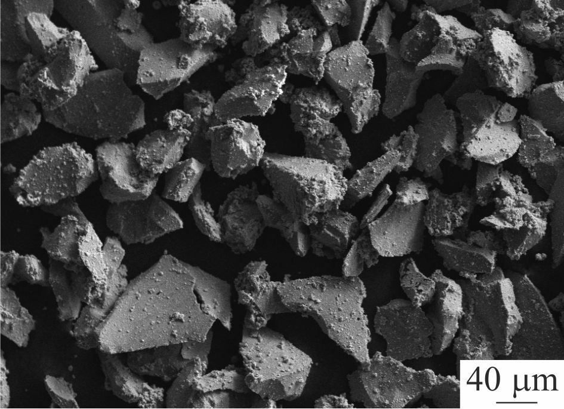
Fig. 1. The particles of В₄С-Ni-Р powder

General technical recommendations:
figures should have dimensions corresponding to its informativeness: 8–8.5 cm (one column) or 17–17.5 cm (two columns);
for photos it is desirable to provide a variant without text and all notation; for the remaining illustrations, place inscriptions in the illustration so that they do not come into contact with any of its parts;
in photographs (for example, structures), dimensional marks should be indicated;
use standard TrueType fonts for labels and notations;
please do not add to the background of illustrations a gray (colored) background or a grid;
graphics and diagrams are preferably prepared in vector graphics editors;
- should have a resolution of at least 600 dpi;
- the thickness of the lines should be at least 0.5 pt;
- vector illustrations should not contain dot shades, such as “Noise”, “Black & white noise”, “Top noise”;
- for vector graphics, all used fonts should be included in the file.
Line illustrations:
Halftone Illustrations:
- should have a resolution of at least 300 dpi
Combined halftone/line art illustration:
- should have a resolution of at least 600 dpi.
4. Conclusions
Conclusions on the results of the work described in the paper; should be concise.
References
The list of cited references includes sources containing materials that the author used to write the paper, and is drawn up according to the samples given below. The composition of the literature sources should reflect the state of scientific research in different countries in the problem area under consideration.
Links should be available to the scientific community, so DOI publication is welcome.
The number of references should not be less than 20 with more (more than 50%) shares of foreign sources.
References in the text are given in square brackets, for example [1] or [2–5]. Numbering of sources should correspond to the order of its references in the text.
References to the author's abstracts of dissertations, dissertations for a scientific degree are allowed in the presence of its available electronic versions.
References to textbooks, teaching aids, monographs should have a subordinate value and make up no more than 10–15%, since they are inaccessible to the broad scientific community.
Links to unpublished work are inadmissible.
Self-citation should not exceed 15–17%.
If the work was published in both Russian and English (or other) languages, then it is better to give a reference to the translation work in References.
In connection with the publication of the journal in the citation of scientific publications, in addition to the traditional References (GOST 7.0.5-2008), an additional list is needed with the translation of Russian-language sources into Latin and English. Transliteration is strictly applied using the BSI system (see http://www.translit.net/?account=bsi).
Funding
Indicate the source(s) of the research funding (if any, for example, a grant), using, for example, the following: “The study is carried out with financial support ...”.
Conflicts of Interest
Identify the existence of so-called conflicts of interest, that is, conditions and facts that can influence the results of the study (for example, funding from stakeholders and companies, their participation in discussing research results, writing a manuscript, etc.). In the absence of such, the following wording should be used: “The authors state that there is no conflict of interest”.
Acknowledgements
It is possible to express gratitude to those whose contribution to the study is insufficient to be recognized as their co-authors, but at the same time considered authors to be significant (consultations, technical assistance, translations, etc.).

ON THE NEXT PAGE
Information for RSCI

Section MATERIAL SCIENCE

¹ Kornienko Elena E., ² Kuz’min Viktor I., ³ Sivkov Alexander A.

¹ Novosibirsk State Technical University, 20 Prospect K. Marksa, Novosibirsk, 630073, Russian Federation
² Khristianovich Institute of Theoretical and Applied Mechanics SB RAS, 4/1 Institutskaya str., Novosibirsk, 630090, Russian Federation
³ National Research Tomsk Polytechnic University, 30 Lenin Avenue, Tomsk, 634050, Russian Federation

Kornienko E.E. ORCID: http://orcid.org/0000-0002-5874-5422, e-mail: kornienko_ee@mail.ru
Kuz’min V.I. ORCID: http://orcid.org/0000-0002-9951-7821, e-mail: vikuzmin57@mail.ru
Sivkov A.A. ORCID: http://orcid.org/0000-0002-7685-5502, e-mail: SivkovAA@mail.ru.

Structure features of B₄C-Ni-Р plasma coatings

Abstract for a paper should be: informative (do not contain general words); original (to reflect the main content of the paper and the results of the research); structured (follow the logic of describing the results in the paper). The volume of the abstract should be at least 250 words!!! The abstract should include the following aspects of the content of the paper: the rationale, the subject, the purpose of the work; method or methodology of the work; results of work; the field of application of the results; conclusions.

UDC 621.793.71

Keywords:
Plasma spraying, Boron carbide, B₄C-Ni-P, Coating

References
- Bor v yadernoi tekhnike [Boron in nuclear engineering]. Dimitrovgrad, OJSC «GNTs NIIAR», 2011. – 668 p. ISBN 5-9483-016-7.
- Fabrication and Tribological Evaluation of Vacuum Plasma-Sprayed B₄C / H. Zhu, Y. Niu, C. Lin, L. Huang, H. Ji, X. Zheng // Coating Journal of Thermal Spray Technology. – 2012. – Vol. 21. – Iss. 6. – P. 1216-1223. – doi: 10.1007/s11666-012-9815-5.
(List the literature should be formally established in accordance with GOST R 7.05-2008 “Bibliographic reference”. The number of references should not be less than 20 with larger fraction (more than 50%) of foreign sources.)

Funding:
The work is carried out within the framework of the TPU competitiveness increase program among the world's leading research centers.

Received: 01.06.2017 (Date of receipt of work in the editorial board. Important: the work should arrive not later than 3 months before the official issue according to the schedule. In exceptional cases, in agreement with the editorial board of the journal, the deadline for the receipt of the paper in the nearest issue may be extended, but not more than for two weeks.)

